Prescriptive Grammar

🔹 What is Prescriptive Grammar
# Source: AI Source: Provided by: [Data Path: Persons Table -> ID Column: 1, Name_En Column: Motasem Essam] -> From: [Chatgpt (GPT-4-turbo)] on [8/3/2025]
Prescriptive grammar is a set of rules and norms that dictate how language should be used. It defines what is considered “correct” or “proper” according to traditional standards—often based on standard written English or classical grammar traditions.
This is the kind of grammar typically taught in schools, style guides, and language textbooks.

✅ Key Features of Prescriptive Grammar:
# Source: AI Source: Provided by: [Data Path: Persons Table -> ID Column: 1, Name_En Column: Motasem Essam] -> From: [Chatgpt (GPT-4-turbo)] on [8/3/2025]
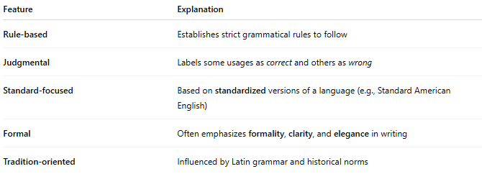
Feature | Explanation
Rule-based | Establishes strict grammatical rules to follow
Judgmental | Labels some usages as correct and others as wrong
Standard-focused | Based on standardized versions of a language (e.g., Standard American English)
Formal | Often emphasizes formality, clarity, and elegance in writing
Tradition-oriented | Influenced by Latin grammar and historical norms

✅ Examples of Prescriptive Grammar Rules:
# Source: AI Source: Provided by: [Data Path: Persons Table -> ID Column: 1, Name_En Column: Motasem Essam] -> From: [Chatgpt (GPT-4-turbo)] on [8/3/2025]
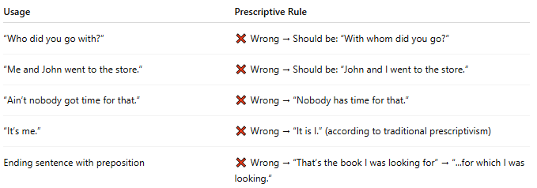
Usage | Prescriptive Rule
“Who did you go with?” | ❌ Wrong → Should be: “With whom did you go?”
“Me and John went to the store.” | ❌ Wrong → Should be: “John and I went to the store.”
“Ain’t nobody got time for that.” | ❌ Wrong → “Nobody has time for that.”
“It’s me.” | ❌ Wrong → “It is I.” (according to traditional prescriptivism)
Ending sentence with preposition | ❌ Wrong → “That’s the book I was looking for” → “...for which I was looking.”

✅ Prescriptive Grammar vs. Descriptive Grammar:
# Source: AI Source: Provided by: [Data Path: Persons Table -> ID Column: 1, Name_En Column: Motasem Essam] -> From: [Chatgpt (GPT-4-turbo)] on [8/3/2025]
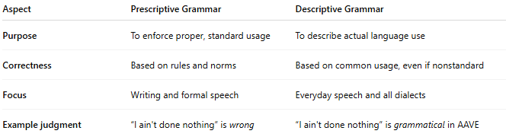
Aspect | Prescriptive Grammar | Descriptive Grammar
Purpose | To enforce proper, standard usage | To describe actual language use
Correctness | Based on rules and norms | Based on common usage, even if nonstandard
Focus | Writing and formal speech | Everyday speech and all dialects
Example judgment | “I ain't done nothing” is wrong | “I ain't done nothing” is grammatical in AAVE

✅ Why Prescriptive Grammar Matters:
# Source: AI Source: Provided by: [Data Path: Persons Table -> ID Column: 1, Name_En Column: Motasem Essam] -> From: [Chatgpt (GPT-4-turbo)] on [8/3/2025]
- Essential for formal writing, public speaking, and academic standards
- Ensures clarity, consistency, and professionalism
- Important in education, editing, law, journalism, etc.

📝 Summary:
# Source: Chatbot (GPT-4-turbo) at [8/3/2025]
- Prescriptive grammar = How people should speak and write
- Rooted in rules, standard forms, and tradition
- Focuses on correctness and proper usage
- Often contrasted with descriptive grammar, which looks at how language is actually used

